27.66: a) F = ILB, to the right.
b) 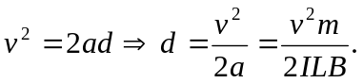
c) 